CAMPUS RECRUITMENT SYSTEM

**(Forms and Tables)**

**Submitted To, Submitted By,**

**Ms. Dilu Maria Joseph Jaimi Santhosh**

**Date:30/07/2020 INTMCA-S9**

**Registration form (Company)**

|  |
| --- |
| Company Name  Address  Mobile  Website  Email  Username  Password  Confirm Password |

**SIGN IN**

|  |
| --- |
| Username  Password  LOGIN  Forgot password  Not a member? Register here |

**Registration Form (Jobseeker)**

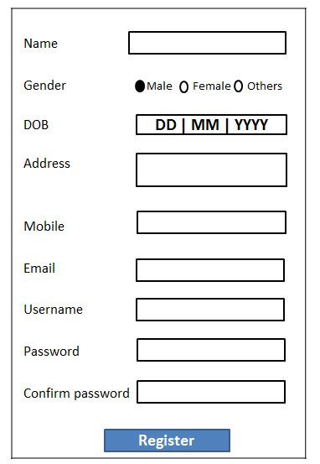

**Forgot password**

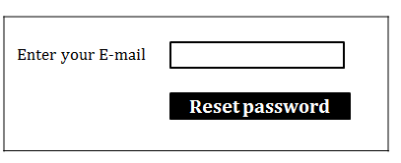

**View Company details**

|  |
| --- |
| Company name  VIEW |

**View jobseeker details**

|  |
| --- |
| Admission No  VIEW |

**Jobseeker Education**

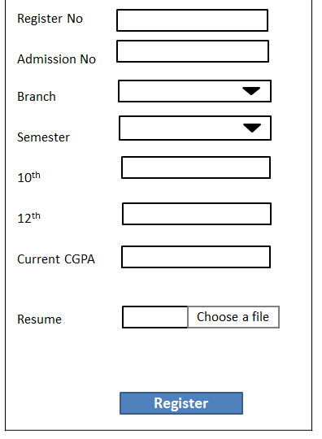

**Job post**

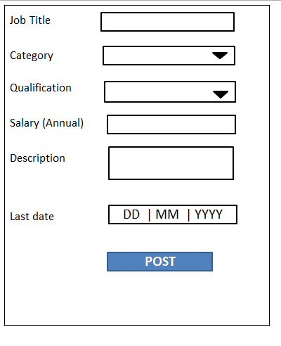

**Search**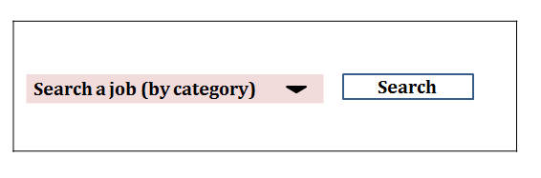

**Posting Placement papers**

|  |
| --- |
| Choose a file    UPLOAD |

**Add branch Add qualification**

|  |  |  |  |  |  |  |  |  |  |  |  |  |  |  |  |  |  |  |  |  |  |  |  |  |  |  |  |  |  |  |  |  |  |  |  |  |  |  |  |  |
| --- | --- | --- | --- | --- | --- | --- | --- | --- | --- | --- | --- | --- | --- | --- | --- | --- | --- | --- | --- | --- | --- | --- | --- | --- | --- | --- | --- | --- | --- | --- | --- | --- | --- | --- | --- | --- | --- | --- | --- | --- |
| Enter branch **Add qualification**   |  |  |  |  |  | | --- | --- | --- | --- | --- | | Sl.No | Column name | Data Type | Length | Description | | 1 | sem_id | integer | 10 | Primary key | | 2 | Login_id | integer | 10 | Foreign key from tbl_login | | 3 | semester | varchar | 20 | semeters |   name  Enter qualification**Add qualification**   |  |  |  |  |  | | --- | --- | --- | --- | --- | | Sl.No | Column name | Data Type | Length | Description | | 1 | sem_id | integer | 10 | Primary key | | 2 | Login_id | integer | 10 | Foreign key from tbl_login | | 3 | semester | varchar | 20 | semeters |   name  ADD  ADD |

|  |
| --- |
|  |

**Add job categories Add semesters**

|  |  |  |  |  |  |  |  |  |  |  |  |  |  |  |  |  |  |  |  |  |  |  |  |  |  |  |  |  |  |  |  |  |  |  |  |  |  |  |  |  |  |  |
| --- | --- | --- | --- | --- | --- | --- | --- | --- | --- | --- | --- | --- | --- | --- | --- | --- | --- | --- | --- | --- | --- | --- | --- | --- | --- | --- | --- | --- | --- | --- | --- | --- | --- | --- | --- | --- | --- | --- | --- | --- | --- | --- |
| Enter job category **Add qualification**   |  |  |  |  |  | | --- | --- | --- | --- | --- | | Sl.No | Column name | Data Type | Length | Description | | 1 | sem_id | integer | 10 | Primary key | | 2 | Login_id | integer | 10 | Foreign key from tbl_login | | 3 | semester | varchar | 20 | semeters |   name  ADD |  | ADD  Enter semester **Add qualification**   |  |  |  |  |  | | --- | --- | --- | --- | --- | | Sl.No | Column name | Data Type | Length | Description | | 1 | sem_id | integer | 10 | Primary key | | 2 | Login_id | integer | 10 | Foreign key from tbl_login | | 3 | semester | varchar | 20 | semeters |   name |

**feedback**

|  |
| --- |
| Type your feedback here    SEND |

**Job Approve/Reject**

|  |
| --- |
| Approve Reject  Type comments  SAVE |

**tbl_login**

|  |  |  |  |  |
| --- | --- | --- | --- | --- |
| **Sl.No** | **Column Names** | **Data Type** | **Length** | **Description** |
| 1 | Login_id | Integer | 10 | Primary Key |
| 2 | Username | Varchar | 20 | Username |
| 3 | Password | Varchar | 20 | Password |
| 4 | Role_type | Varchar | 20 | Types of roles |

**Company_Reg**

|  |  |  |  |  |
| --- | --- | --- | --- | --- |
| **Sl.No** | **Column Names** | **Data Type** | **Length** | **Description** |
| 1 | cid | Integer | 10 | Primary Key |
| 2 | Login_id | integer | 10 | Foreign key from tbl_login table |
| 3 | Company_Name | Varchar | 20 | Name of Company |
| 4 | Address | Varchar | 20 | Address of company |
| 5 | Mobile | Numeric | 20 | Mobile Number |
| 6 | Website | Varchar | 20 | Company website |
| 7 | Email | Varchar | 20 | E-mail address of company |

**Company_job_post**

|  |  |  |  |  |
| --- | --- | --- | --- | --- |
| **Sl.No** | **Column Names** | **Data Type** | **Length** | **Description** |
| 1 | Job_id | Integer | 10 | Primary Key |
| 2 | cid | integer | 10 | Foreign key from Company_Reg |
| 3 | Category_id | integer | 10 | Foreign key from category table |
| 4 | Qualification_id | varchar | 20 | Foreign key from qualification table |
| 5 | Job title | Varchar | 20 | Role for Job seeker |
| 7 | salary | Integer | 20 | Expected salary of the job |
| 8 | Description | varchar | 20 | Description about job |
| 9 | Last_apply_date | date | 10 | Expiry date for applying the job |

**Mock_test**

|  |  |  |  |  |
| --- | --- | --- | --- | --- |
| **Sl.No** | **Column Names** | **Data Type** | **Length** | **Description** |
| 1 | Qn_no | Integer | 10 | Primary Key |
| 2 | cid | integer | 10 | Foreign key from Company_Reg |
| 3 | Question | Varchar | 20 | Questions |
| 4 | Choice 1 | Varchar | 20 | Answer 1 |
| 5 | Choice 2 | varchar | 20 | Answer 2 |
| 6 | Choice 3 | Varchar | 20 | Answer 3 |
| 7 | Correct_ans | Varchar | 20 | Correct Answer |

**User_Reg**

|  |  |  |  |  |
| --- | --- | --- | --- | --- |
| **Sl.No** | **Column Names** | **Data Type** | **Length** | **Description** |
| 1 | User_id | Integer | 10 | Primary Key |
| 2 | Login_id | integer | 10 | Foreign key from tbl_login |
| 2 | Name | Varchar | 10 | Name of Jobseeker |
| 3 | Gender | integer | 10 | Gender of jobseeker |
| 4 | DOB | date | 10 | DOB of jobseeker |
| 5 | Address | Varchar | 10 | Address of jobseeker |
| 6 | Mobile No | Numeric | 10 | Mobile no of Jobseeker |
| 7 | Email_id | Varchar | 10 | Email_id of jobseeker |

**Jobseeker_education**

|  |  |  |  |  |
| --- | --- | --- | --- | --- |
| **Sl.No** | **Column Names** | **Data Type** | **Length** | **Description** |
| 1 | Id | Integer | 10 | Primary Key |
| 2 | Reg_id | integer | 10 | Foreign key from user_Reg |
| 3 | Branch_id | integer | 10 | foreign key from tbl_branch |
| 4 | Sem_id | integer | 10 | Foreign_key from tbl_semseter |
| 3 | Reg_no | varchar | 20 | University register number |
| 4 | Adm_no | integer | 20 | Admission number of jobseeker |
| 8 | 10th | float | 10 | CGPA in 10th |
| 9 | 12th | float | 10 | CGPA in 12th |
| 8 | CGPA | float | 10 | Current CGPA of jobseeker |
| 10 | Resume | varchar | 10 | Upload resume as a pdf file |

**Notification_master**

|  |  |  |  |  |
| --- | --- | --- | --- | --- |
| **Sl.No** | **Column Names** | **Data Type** | **Length** | **Description** |
| 1 | Notfn_Id | Integer | 10 | Primary Key |
| 2 | Job_id | integer | 10 | Foreign key from user_reg table |
| 3 | notification | varchar | 20 | Notifications about the job |
| 4 | date | date | 10 | Date of publishing |

**Jobseeker_feedback**

|  |  |  |  |  |
| --- | --- | --- | --- | --- |
| **Sl.No** | **Column Names** | **Data Type** | **Length** | **Description** |
| 1 | Feedback_id | Integer | 10 | Primary Key |
| 2 | User_id | integer | 10 | Foreign key from user_Reg |
| 3 | feedback | Varchar | 20 | Feedback from jobseeker |

**Applied_jobs**

|  |  |  |  |  |
| --- | --- | --- | --- | --- |
| **Sl.No** | **Column Names** | **Data Type** | **Length** | **Description** |
| 1 | Apply_id | integer | 10 | Primary key |
| 2 | User_id | integer | 10 | Foreign key from user_Reg |
| 3 | Job_id | integer | 10 | Foreign key from company_job_post |
| 4 | status | varchar | 20 | Status of the applied job |
| 5 | description | varchar | 20 | description |

**Add_Placement_papers**

|  |  |  |  |  |
| --- | --- | --- | --- | --- |
| **Sl.No** | **Column names** | **Data type** | **length** | **Description** |
| 1 | Paper_id | integer | 10 | Primary key |
| 2 | cid | integer | 10 | Foreign key from Company_Reg |
| 3 | file | varchar | 20 | Placement pdf file |

**Category**

|  |  |  |  |  |
| --- | --- | --- | --- | --- |
| **Sl.No** | **Column name** | **Data Type** | **Length** | **Description** |
| 1 | Category_id | integer | 10 | Primary key |
| 2 | Login_id | integer | 10 | Foreign key from tbl_login |
| 3 | Category_name | varchar | 20 | Role of the Jobseeker |

**Tbl_branch**

|  |  |  |  |  |
| --- | --- | --- | --- | --- |
| **Sl.No** | **Column name** | **Data Type** | **Length** | **Description** |
| 1 | branch_id | integer | 10 | Primary key |
| 2 | Login_id | integer | 10 | Foreign key from tbl_login |
| 3 | Branch_name | varchar | 20 | Branch names |

**Tbl_semester**

|  |  |  |  |  |
| --- | --- | --- | --- | --- |
| **Sl.No** | **Column name** | **Data Type** | **Length** | **Description** |
| 1 | sem_id | integer | 10 | Primary key |
| 2 | Login_id | integer | 10 | Foreign key from tbl_login |
| 3 | semester | varchar | 20 | semesters |

**Tbl_qualification**

|  |  |  |  |  |
| --- | --- | --- | --- | --- |
| **Sl.No** | **Column name** | **Data Type** | **Length** | **Description** |
| 1 | qualification_id | integer | 10 | Primary key |
| 2 | Login_id | integer | 10 | Foreign key from tbl_login |
| 3 | qualification | varchar | 20 | Qualification of the jobseeker |